Association of leather, footwear and fur enterprises of Uzbekistan “UZCHARMSANOAT”

State Committee for Family and Women of Uzbekistan
Ministry of Higher Education, Science and Innovations
of Uzbekistan
Tashkent Institute of Textile and Light Industry

REGULATIONS
OF THE 1st INTERNATIONAL CONTEST FOR YOUNG DESIGNERS OF SHOE, ACCESSORIES, LEATHER AND FUR PRODUCTS
“UZCHARM Style 2023”
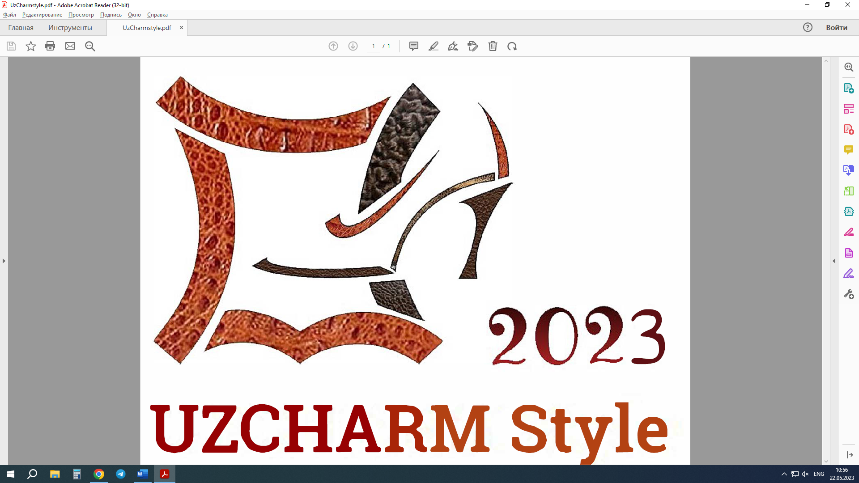

TASHKENT 2023
Chairman of the Association
“Uzcharmsanoat”
_________ F.Boboev
"____"_______ 2023

Chairman  State Committee for  Family and Women  ________ O.Parpiboeva  "____"________ 2023 | Rector  Tashkent Institute of  Textile and Light Industry  _________ D.Vakhabov  "____"_______ 2023

Regulations
on holding the 1st International Contest for Young Designers in the field of design, technology of footwear, accessories, leather and fur clothing
“UZCHARM STYLE-2023”

General provisions
The 1st International Contest for Young designers in the field of design, technology of footwear, accessories, leather and fur clothing is promoted by the “Uzcharmsanoat” Association in partnership with the State Committee for Family and Women in collaboration with Tashkent Institute of Textile and Light Industry, is carried out with the aim of:
• identifying and stimulating talented designers of shoes, clothing, and items made of leather and fur among students studying in institutions of higher and secondary specialized education;
• raising the status of the designer’s profession in the field of leather and fur products;
• selection of promising collections for further implementation;
• formation of communications between designers and industrial enterprises.
These Regulations establish the principles of organizing, holding and summing up the results of the 1st International Contest for Young Designers in the field of construction, technology and design of shoes, clothing and items made of leather and fur “UZCHARM STYLE-2023” (hereinafter referred to as the Contest).

1.ORGANIZATION OF THE CONTEST
1.1. Contest organizers.
The Contest is promoted by “Uzcharmsanoat” Association, in partnership with State Committee for Family and Women of Uzbekistan and Tashkent Institute of Textile and Light Industry (hereinafter referred to as the Organizer).
1.2. Organizer:
1.2.1. is the main governing body of the Contest, carries out general management and control;
1.2.2. carries out operational management of events within the framework of the Contest and control over compliance with this Regulation;
1.2.3. approves the composition of the Organizing Committee of the Contest;
1.2.4. attracts partners and sponsors of the Contest;
1.2.5. provides organizational, technical and methodological support for the Contest, the activities of the Jury (organizes the awarding of winners and prize-winners of the Contest, and others).
1.3. The composition of the Jury of the Contest is approved by the Chairman of the Organizing Committee from among the leaders of leading specialists, fashion designers and members of the Organizing Committee.
1.4. Contest Jury:
1.4.1. evaluates the work of participants;
1.4.2. provides unity of criteria for selection of winners and laureates of the Contest;
1.4.3. evaluates works, participates in the awarding of winners and laureates of the Contest. The jury evaluates creative works (sketches and models) as well as a theoretical and practical task and makes a decision individually. The decision of each jury member is documented in a protocol. The decision of the jury members is not subject to revision.
1.4.4. Based on individual assessments, the average score for each criterion and the final score are determined as the sum of the average scores.

2. PROCEDURE AND TERMS OF THE CONTEST
2.1. The Contest is held in the following nominations:
• “The best design of men's shoes”;
• “The best design of women's shoes”;
• “The best design of children's and teenage shoes”;
• “The best design of leather goods and accessories”;
• “The best design of sporting goods”;
• “The best design of men's and women's clothing made of leather”;
• “The best design of clothes from fur”.
Works made of fur, leather and other materials can be submitted to the Contest.
2.2. Description of the Contest nominations
In the nomination “The best design of men's shoes”, sketches and samples of a collection of model or casual men's shoes should be presented (the number of samples presented in the collection is 3-5 pairs).
In the nomination “The best design of women's shoes”, sketches and samples of a collection of women's model or casual shoes are presented (the number of samples presented in the collection is 3-5 pairs).
In the nomination “The best design of children's and teenage shoes” sketches and samples of a collection of children's or teenage shoes for all age groups are presented (the number of samples presented in the collection is 3-5 pairs).
In the nomination “The best design of leather goods and accessories” presents sketches and samples of the collection of accessories - bags, purses, wallets, gloves, belts (the number of presented samples in the collection is 3-5 items).
In the nomination "Best design of sporting goods"; sketches and samples of sports products are presented: shoes (for sports or industrial shoes), gloves, paws, etc. (the number of samples presented in the collection is 3-5 products).
In the nomination “The best design of men's and women's clothing” made of leather, sketches and samples of models of men's and women's clothing, leather hats are presented - (the number of presented products there is 3-4 products in the collection.)
In the nomination “The best design of clothes made of fur”, sketches and samples of models of men's and women's clothing, fur hats are presented (the number of presented items in the collection is 3-4 items).
2.3. Competitors:
2.3.1. The Contest is open to all students of specialized educational institutions in the field of design, construction and technology of manufacturing shoes, clothing and accessories, from 18 th up to 30 years old;
2.3.2. The participation on the Contest is free. There are no registration fees.
2.3.3. Participation in the competition can be in ON-LINE format or face-to-face.
All contestants must register online by filling up the application form at www.mittelmoda.com/register.
Registrations are open from the date of the forwarding of this call for application (20th February 2023)
and will close on 30th June 2023 at 23.59 CEST.
All participants must register by filling up the Application Form with a photo of the participant 3X4 cm (Appendix 1), and send it with a copy of the passport and competitive works to the email address uzcharmstyle2023@gmail.com or deliver
to the Tashkent Institute of Textile and Light Industry at the address Tashkent, Shokhzhakhon St. -5, 1 building office, room N 414. until September 5, 2023 (tel. for inquiries: +99890 1340888, +99899 8778392).
2.4. The Contest is held:
2.4.1. ON-LINE participants represent: application form, sketches, photos and video clips of the collection to the organizing committee, to the email address uzcharmstyle2023@gmail.com until September 5, 2023: (Telegram: +998901340888, +998998778392).
2.4.2. physically participants must submit the Application Form, sketches and presentations (video clips), until September 5, and deliver to the Tashkent Institute of Textile and Light Industry at the address, Tashkent, Shokhzhakhon St. -5, 1 building room 414. or send by e-mail uzcharmstyle2023@gmail.com,
digital format as well as to be directly present with ready-made collections on September 8-11 at the venue of the final stage in Tashkent (the address will be announced later (Telegram: +99890 1340888, +99899 8778392
2.4.3. The awarding ceremony of the winners and laureates will be held on September 12, 2023 in Tashkent (TBC).

2.5. Terms of carrying out.
2.5.1. Acceptance of applications and registration of participants begins
from July 1, 2023 to September 5, 2023.
2.5.2. Evaluation of the work of participants will be held - September 8-11, 2023.
2.5.3. The awardding ceremony and the final day of the Contest will be held on September 12, 2023. (TBC)
2.6 Requirements for competitive works:
2.6.1 sketches of the collection must be made on paper in the format A3 (420X297mm) (2 sheets on each sheet- 3-4 models), sketch series should include at least three and no more than six models; the technical design of the sketches is graphic, it is allowed to use the graphic computer programs Photo Shop, Corel Draw and Mind Shoe design, etc.
2.6.1. Photos of products (in three projections: front, side, back), which are arranged on sheets of A3 format, 1 model, on each sheet indicating the full name author, name of the nomination (in electronic form, file size no more than 5 Mb, jpeg formats)
2.6.3. Each contestant has the right to take part in any nomination, including several at the same time, but with different competitive works;
2.6.4. The author's work must be done solely;
2.7. At the final stage, physically participants must present finished materials, an exhibition and demonstration in front of the Jury is held.
2.7.1. At the final stage of the competition, physically participants must prepare presentations of their work (12-15 slides). Presentations can be made using Power Point presentation software or video editing software.
2.7.2. At the final stage, ON-LINE participants will be judged on sketches, photographs and video presentation of the collection. Requirements for video presentation for participants given in Appendix 2
2.8. The collections and designs can be already submitted and do not have to be exclusively made for the Contest.

3. SUMMING UP THE RESULTS OF THE CONTEST, ANNOUNCING AND AWARDING THE WINNERS AND LAUREATES OF THE CONTEST
3.1. Competitive collections will be evaluated according to the following criteria:
aesthetic value of the collection, compliance with current trends;
• the integrity of the compositional solution, the combination of colors and textures of materials, the selection of materials; persistence of a certain style
the collection contains structural and technological finds;
• practical application, and the possibility of implementation at the enterprises of the industry;
• quality and technique of products execution;
• level of presentation and demonstrated theoretical knowledge.

The projects will be evaluated by a jury made up by qualified experts. The evaluation will be based on the criteria presented on the Appendix 3:
3.2.1. The winners of the Contest are determined on the basis of the Jury's assessments, who received the maximum number of points in the nomination.
3.2.2. The number of prizes is regulated by the Organizing Committee
and the Jury.
3.2.3. The winners of the competition, who took the first place, are awarded with diplomas (certificates) and a valuable gift (Laptop) from the Organizers of the Competition in the prescribed manner.
3.2.4. The winners who took the second and third places can be awarded with diplomas (certificates) and valuable gifts (the second place is a tablet, the third place is a graphic tablet of the Organizers of the Competition in the prescribed manner.
3.2.5. The awards ceremony will be held September 12, 2023 in the city of Tashkent.

4. CONDITIONS OF STAY OF PARTICIPANTS AT THE FINAL STAGE:
4.1. Local participants from other cities must arrive at the appointed address within the time limits established by this Organizing Committee.
All participants in the final stage of the Contest, in physical format, must arrive in Tashkent no later than September 8, 2023.
For out-of-town participants: living expenses and travel takes over the sending educational institution.
4.2. Participants of the Contest, by their participation, give their consent to the Organizer of the Contest to be filmed on video, for television or otherwise, photographed during the Contest, and subsequently used the received video, photo, audio, other materials in promotional materials that promote the Contest;
4.3. Participants of the Contest by their participation guarantee that they have the rights to use the sketches, photographs, video clips and collections, works and other materials they submit.
4.4. All relationships on copyright and related rights with copyright societies, other organizations and individuals, the participants of the Contest will settle independently.

5. OTHER PROVISIONS
5.1. Works of the winners of the Contest submitted by the participants of the Contest (residents of the Republic of Uzbekistan) during 10 months can be stored in the showroom of the Association and used at international exhibitions and other events, indicating the author's data.
5.2. By taking part in the Contest, contestant:
• confirms that he is familiar with, agrees with these Regulations of the Contest and undertakes to comply with them;
• gives its consent to the use of photo and video materials by the Organizer without obtaining the prior consent of the Participant of the Contest or notification by the Organizer, as well as without paying any remuneration.
5.3. Decisions of the Organizer on all issues related to with the Contest, as well as the results of the Contest are considered final and apply to all Participants of the Contest.
5.4. The Organizer of the Contest, as well as persons authorized by it, shall not be liable to the Participants for untimely familiarization of the Participants of the Contest with the results of the Contest, as well as for non-fulfillment (late fulfillment) by the Participants of the Contest of the obligations provided for by these Rules.
5.5. The Organizer is not responsible for any consequences of the Participant's errors, including (but not limited to) the costs incurred by the latter.
5.6. During the period of the Contest, the organizer has the right to:
• make changes to the Rules by publishing them on the Contest Organizer's website, as well as on the Internet 1 (one) calendar day before the date such changes come into force;
• announce an additional Stage of the Contest, change the technology, terms and other conditions for determining the results of the Contest by publishing information about it on the website of the Organizer of the Contest 2 (two) calendar days before the effective date of such changes;
5.7. All disputes relating to this Contest are regulated on the basis of the current legislation of the Republic of Uzbekistan.

Appendix 1

photo
«UZСHARM -Style 2023»
1st International Contest for Young Designers of Shoes, Accessories, Leather and Fur Products.

APPLICATION FORM

- Name, Surname. __________________________________________________________________
2. Place of study, (university, faculty, direction of education, specialty)

- Telephone number_______________________________________________
- Е-mail _________________________________________________________
- Nomination ____________________________________________________
7.Collection name__________________________________________________
8.Creation idea______________________________________________________

Brief summary of the participant (participation in Contests, awards and other achievements):
________________________________________________________________________________________________________________________________________________________________________________________________________________________________________________________________________

I have read and agree to the Terms and Conditions of Participation in the Contest
_______________ (signature date)
Appendix 2

REQUIREMENTS FOR VIDEO PREZENTATIONS OF COMPETITION COLLECTIONS
FOR ON-LINE PARTICIPANTS:

Videos presentations (created) by any available means, corresponding to the theme of the competition, are submitted to the competition
Video format: MPEG4 (mp4; mov).
Video quality at least Full HD 1920x1080 (Ultra HD 3840x2160, 4K 4096x3072) The recording must be made strictly in the horizontal position of the screen, aspect ratio 16:9. H.264 compression format
The duration of the video is from 3 to 5 minutes.
Video presentations should be decorated with an information banner with the name of the author, the name educational institution the name nomination the name of collection. The camera is built in such a way that the items that make up the collection get into the frame one by one.
Try to minimize shaking.
Provide sufficient lighting. The use of special programs and tools when editing and shooting a video is up to participant. Photos and sketches may be used in the video.
Advertising videos that offend the dignity and feelings of other people that do not correspond to the theme of the Contest are not accepted for the Contest.

Appendix 3

EVALUATION CRITERIA FOR COMPETITIVE WORKS
OF THE 1ST INTERNATIONAL CONTEST FOR YOUNG DESIGNERS OF SHOE, ACCESSORIES AND LEATHER AND FUR CLOTHES
"UZCHARM Style 2023"

№ | Evaluation Criteria | Maximum score
1 | Aesthetic value of the collection, compliance with current trends, originality | 20
2 | The integrity of the compositional solution, the combination of colors and textures of materials, the selection of materials; consistency of a certain style in the collection | 20
3 | Practical application, the degree of readiness of models for development in production (orientation of models for mass consumers). | 20
4 | Quality and technique of products execution | 20
5 | Level of presentation and demonstrated theoretical knowledge. | 20
 | TOTAL | 100

ORGANISING COMMITTEE
OF THE 1ST INTERNATIONAL CONTEST FOR YOUNG DESIGNERS OF SHOE, ACCESSORIES AND LEATHER AND FUR CLOTHES
"UZCHARM Style 2023"

Chairman of the Organizing Committee | F. Boboev - Chairman of the “Uzcharmsanoat” Association
Deputy Chairman of the Organizing Committee | O.A. Parpiboeva - Chairman of the State Committee for Family and Women
 | D.A. Vakhabov - Rector of the Tashkent Institute of Textile and Light Industry
Members of the organizing committee | A. Sultanov - 1st Deputy Chairman of the “Uzcharmsanoat” Association
 | Sh.Aliyev - Head of the Department of the “Uzcharmsanoat” Association
 | D. Islombekov - Head of the Department of the “Uzcharmsanoat” Association
 | D. Zufarova - Head of Department of the "Uzcharmsanoat" Association
 | K.Narkulova - State Committee for Family and Women, Head of Department, Doctor of Technical Sciences, Professor
 | M. Ilkhamova - PhD, Department of Design and Technology of Leather Products, Tashkent Institute of Textile and Light Industry

JUDGING PANEL
FOR THE 1ST INTERNATIONAL CONTEST FOR YOUNG DESIGNERS OF SHOE, ACCESSORIES AND LEATHER AND FUR clothes
"UZCHARM Style 2023"

Jury President | F. Boboev - Chairman of the “Uzcharmsanoat” Association
Vice-chairman  jury | O.A. Parpiboeva - Chairman of the State Committee for Family and Women
Vice-chairman  jury | D. Vakhabov – Chairman Chamber of Commerce and Industry of Uzbekistan
Jury members | A. Sultanov – First Deputy Chairman of the “Uzcharmsanoat” Association
 | Nikolaos Bilalis - Professor Head of CAD laboratory Technical University of Crete, (Greece)
 | Aura Mihai - Professor, Asachi Technical University, Iasi (Romania).
 | Alexey Dombrov - technical manager of Zund Systemtechnik AG, manufacturer of digital cutting systems (Sweden)
 | Arife Candaş ADIGÜZEL ZENGİN - Professor. Dr. EGE University
 | D. Zufarova - Head of Department of the "Uzcharmsanoat" Association
 | M. Ilkhamova - Ph, Department of Design and Technology of Leather Products, Tashkent Institute of Textile and Light Industry
 | O. Osipov - Director of “Asian Furs” LLC

