All incoming students to the International Hellenic University must use the following information when completing their Learning Agreement, selecting either the Alexandria Campus (Sindos, Thessaloniki) or the Serres Campus.
DETAILS FOR ALEXANDRIA CAMPUS/SINDOS/THESSALONIKI

Name | Faculty/Department | Erasmus code | Country | Administrative contact person name; email
DIETHNES  PANEPISTIMIO ELLADOS  /INTERNATIONAL HELLENIC  UNIVERSITY |  | G THESSAL14 | GREECE | Mrs GEORGIA CHATZOPOULOU  erasmus.in@the.ihu.gr tel+30 2310013712  International and European  Programmes Department Thessaloniki

DETAILS FOR SERRES CAMPUS

Name | Faculty/Department | Erasmus code | Country | Administrative contact person name; email
DIETHNES  PANEPISTIMIO ELLADOS  /INTERNATIONAL HELLENIC  UNIVERSITY |  | G THESSAL14 | GREECE | Ms BAKA Maria eu@cm.ihu.gr  Tel +302321049114  International and European Programmes Department/Serres Campus

These details must appear in their Learning Agreement before it is sent for signature. The
“Faculty/Department” field is mandatory and must be completed. You can find the correct name of the School and Department at the International Hellenic University in the list below:
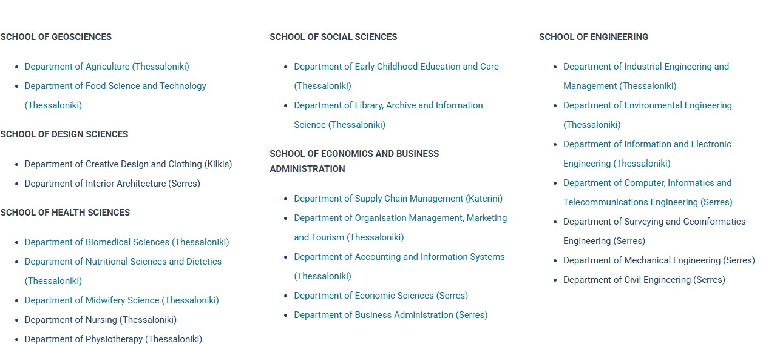
FOR UNDERGRADUATES’ STUDIES
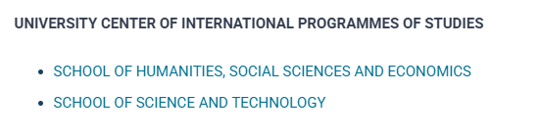

FOR POSTGRADUATES’ STUDIES

Please visti the following link : https://www.ihu.gr/en/postgraduate-studies

Any Learning Agreement that does not contain these details correctly completed will be rejected.

